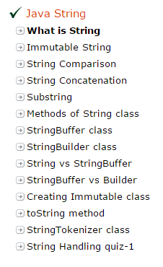

Java String

**Java String** provides a lot of concepts that can be performed on a string such as compare, concat, equals, split, length, replace, compareTo, intern, substring etc.

In java, string is basically an object that represents sequence of char values.

An array of characters works same as java string. For example:

**char**[] ch={'j','a','v','a','t','p','o','i','n','t'};

String s=**new** String(ch);

is same as:

String s="javatpoint";

The java.lang.String class implements *Serializable*, *Comparable* and *CharSequence* interfaces.

The java String is immutable i.e. it cannot be changed but a new instance is created. For mutable class, you can use StringBuffer and StringBuilder class.

We will discuss about immutable string later. Let's first understand what is string in java and how to create the string object.

### **What is String in java**

Generally, string is a sequence of characters. But in java, string is an object that represents a sequence of characters. String class is used to create string object.

### **How to create String object?**

|  |
| --- |
| There are two ways to create String object:   1. By string literal 2. By new keyword |

### **1) String Literal**

Java String literal is created by using double quotes. For Example:

String s="welcome";

Each time you create a string literal, the JVM checks the string constant pool first. If the string already exists in the pool, a reference to the pooled instance is returned. If string doesn't exist in the pool, a new string instance is created and placed in the pool. For example:

String s1="Welcome";

String s2="Welcome";//will not create new instance

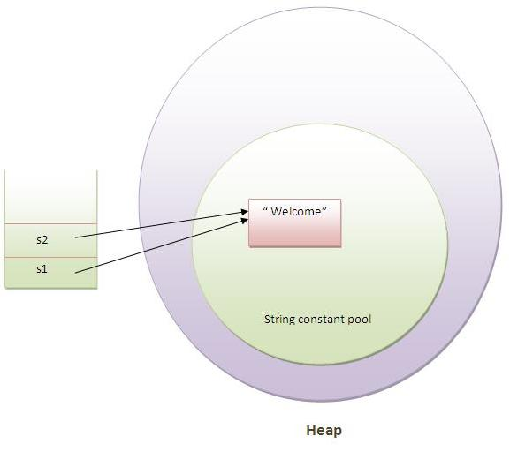

In the above example only one object will be created. Firstly JVM will not find any string object with the value "Welcome" in string constant pool, so it will create a new object. After that it will find the string with the value "Welcome" in the pool, it will not create new object but will return the reference to the same instance.

#### Note: String objects are stored in a special memory area known as string constant pool.

### **Why java uses concept of string literal?**

To make Java more memory efficient (because no new objects are created if it exists already in string constant pool).

### **2) By new keyword**

String s=**new** String("Welcome");//creates two objects and one reference variable

In such case, JVM will create a new string object in normal(non pool) heap memory and the literal "Welcome" will be placed in the string constant pool. The variable s will refer to the object in heap(non pool).

### **Java String Example**

**public** **class** StringExample{

**public** **static** **void** main(String args[]){

String s1="java";//creating string by java string literal

**char** ch[]={'s','t','r','i','n','g','s'};

String s2=**new** String(ch);//converting char array to string

String s3=**new** String("example");//creating java string by new keyword

System.out.println(s1);

System.out.println(s2);

System.out.println(s3);

}

}

java

strings

example

### **Java String class methods**

The java.lang.String class provides many useful methods to perform operations on sequence of char values.

|  |  |  |
| --- | --- | --- |
| No. | Method | Description |
| 1 | [char charAt(int index)](http://www.javatpoint.com/java-string-charat) | returns char value for the particular index |
| 2 | [int length()](http://www.javatpoint.com/java-string-length) | returns string length |
| 3 | [static String format(String format, Object... args)](http://www.javatpoint.com/java-string-format) | returns formatted string |
| 4 | [static String format(Locale l, String format, Object... args)](http://www.javatpoint.com/java-string-format) | returns formatted string with given locale |
| 5 | [String substring(int beginIndex)](http://www.javatpoint.com/java-string-substring) | returns substring for given begin index |
| 6 | [String substring(int beginIndex, int endIndex)](http://www.javatpoint.com/java-string-substring) | returns substring for given begin index and end index |
| 7 | [boolean contains(CharSequence s)](http://www.javatpoint.com/java-string-contains) | returns true or false after matching the sequence of char value |
| 8 | [static String join(CharSequence delimiter, CharSequence... elements)](http://www.javatpoint.com/java-string-join) | returns a joined string |
| 9 | [static String join(CharSequence delimiter, Iterable<? extends CharSequence> elements)](http://www.javatpoint.com/java-string-join) | returns a joined string |
| 10 | [boolean equals(Object another)](http://www.javatpoint.com/java-string-equals) | checks the equality of string with object |
| 11 | [boolean isEmpty()](http://www.javatpoint.com/java-string-isempty) | checks if string is empty |
| 12 | [String concat(String str)](http://www.javatpoint.com/java-string-concat) | concatinates specified string |
| 13 | [String replace(char old, char new)](http://www.javatpoint.com/java-string-replace) | replaces all occurrences of specified char value |
| 14 | [String replace(CharSequence old, CharSequence new)](http://www.javatpoint.com/java-string-replace) | replaces all occurrences of specified CharSequence |
| 15 | [String trim()](http://www.javatpoint.com/java-string-trim) | returns trimmed string omitting leading and trailing spaces |
| 16 | [String split(String regex)](http://www.javatpoint.com/java-string-split) | returns splitted string matching regex |
| 17 | [String split(String regex, int limit)](http://www.javatpoint.com/java-string-split) | returns splitted string matching regex and limit |
| 18 | [String intern()](http://www.javatpoint.com/java-string-intern) | returns interned string |
| 19 | [int indexOf(int ch)](http://www.javatpoint.com/java-string-indexof) | returns specified char value index |
| 20 | [int indexOf(int ch, int fromIndex)](http://www.javatpoint.com/java-string-indexof) | returns specified char value index starting with given index |
| 21 | [int indexOf(String substring)](http://www.javatpoint.com/java-string-indexof) | returns specified substring index |
| 22 | [int indexOf(String substring, int fromIndex)](http://www.javatpoint.com/java-string-indexof) | returns specified substring index starting with given index |
| 23 | [String toLowerCase()](http://www.javatpoint.com/java-string-tolowercase) | returns string in lowercase. |
| 24 | [String toLowerCase(Locale l)](http://www.javatpoint.com/java-string-tolowercase) | returns string in lowercase using specified locale. |
| 25 | [String toUpperCase()](http://www.javatpoint.com/java-string-touppercase) | returns string in uppercase. |
| 26 | [String toUpperCase(Locale l)](http://www.javatpoint.com/java-string-touppercase) | returns string in uppercase using specified locale. |

# Immutable String in Java

In java, **string objects are immutable**. Immutable simply means unmodifiable or unchangeable.

Once string object is created its data or state can't be changed but a new string object is created.

Let's try to understand the immutability concept by the example given below:

**class** Testimmutablestring{

**public** **static** **void** main(String args[]){

    String s="Sachin";

    s.concat(" Tendulkar");//concat() method appends the string at the end

     System.out.println(s);//will print Sachin because strings are immutable objects

  }

}

Output:Sachin

Now it can be understood by the diagram given below. Here Sachin is not changed but a new object is created with sachintendulkar. That is why string is known as immutable.

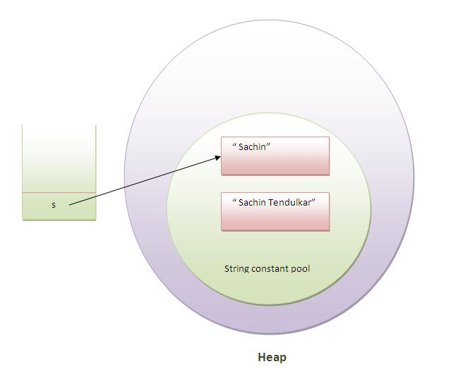

As you can see in the above figure that two objects are created but s reference variable still refers to "Sachin" not to "Sachin Tendulkar".

But if we explicitely assign it to the reference variable, it will refer to "Sachin Tendulkar" object.For example:

**class** Testimmutablestring1{

**public** **static** **void** main(String args[]){

    String s="Sachin";

    s=s.concat(" Tendulkar");

    System.out.println(s);

  }

}

Output:Sachin Tendulkar

In such case, s points to the "Sachin Tendulkar". Please notice that still sachin object is not modified.

### **Why string objects are immutable in java?**

|  |
| --- |
| Because java uses the concept of string literal.Suppose there are 5 reference variables,all referes to one object "sachin".If one reference variable changes the value of the object, it will be affected to all the reference variables. That is why string objects are immutable in java. |

Java String compare

We can compare string in java on the basis of content and reference.

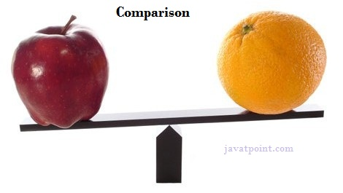It is used in **authentication** (by equals() method), **sorting** (by compareTo() method), **reference matching** (by == operator) etc.

There are three ways to compare string in java:

1. By equals() method
2. By = = operator
3. By compareTo() method

## **1) String compare by equals() method**

The String equals() method compares the original content of the string. It compares values of string for equality. String class provides two methods:

* **public boolean equals(Object another)** compares this string to the specified object.
* **public boolean equalsIgnoreCase(String another)** compares this String to another string, ignoring case.

**class** Teststringcomparison1{

**public** **static** **void** main(String args[]){

    String s1="Sachin";

    String s2="Sachin";

    String s3=**new** String("Sachin");

    String s4="Saurav";

    System.out.println(s1.equals(s2));//true

    System.out.println(s1.equals(s3));//true

    System.out.println(s1.equals(s4));//false

  }

}

Output:true

true

false

**class** Teststringcomparison2{

**public** **static** **void** main(String args[]){

    String s1="Sachin";

    String s2="SACHIN";

    System.out.println(s1.equals(s2));//false

    System.out.println(s1.equalsIgnoreCase(s3));//true

  }

}

Output:false

True

## **2) String compare by == operator**

The = = operator compares references not values.

**class** Teststringcomparison3{

**public** **static** **void** main(String args[]){

    String s1="Sachin";

    String s2="Sachin";

    String s3=**new** String("Sachin");

    System.out.println(s1==s2);//true (because both refer to same instance)

    System.out.println(s1==s3);//false(because s3 refers to instance created in nonpool)

  }

}

Output:true

False

## **3) String compare by compareTo() method**

The String compareTo() method compares values lexicographically and returns an integer value that describes if first string is less than, equal to or greater than second string.

Suppose s1 and s2 are two string variables. If:

* **s1 == s2** :0
* **s1 > s2**  :positive value
* **s1 < s2**  :negative value

1. **class** Teststringcomparison4{
2. **public** **static** **void** main(String args[]){
3. String s1="Sachin";
4. String s2="Sachin";
5. String s3="Ratan";
6. System.out.println(s1.compareTo(s2));//0
7. System.out.println(s1.compareTo(s3));//1(because s1>s3)
8. System.out.println(s3.compareTo(s1));//-1(because s3 < s1 )
9. }
10. }

[**Test it Now**](http://www.javatpoint.com/opr/test.jsp?filename=Teststringcomparison4)

Output:0

1

-1

# String Concatenation in Java

In java, string concatenation forms a new string that is the combination of multiple strings. There are two ways to concat string in java:

1. By + (string concatenation) operator
2. By concat() method

## **1) String Concatenation by + (string concatenation) operator**

Java string concatenation operator (+) is used to add strings. For Example:

**class** TestStringConcatenation1{

**public** **static** **void** main(String args[]){

   String s="Sachin"+" Tendulkar";

   System.out.println(s);//Sachin Tendulkar

  }

}

Output:Sachin Tendulkar

The **Java compiler transforms** above code to this:

String s=(**new** StringBuilder()).append("Sachin").append(" Tendulkar).toString();

In java, String concatenation is implemented through the StringBuilder (or StringBuffer) class and its append method. String concatenation operator produces a new string by appending the second operand onto the end of the first operand. The string concatenation operator can concat not only string but primitive values also. For Example:

**class** TestStringConcatenation2{

**public** **static** **void** main(String args[]){

    String s=50+30+"Sachin"+40+40;

    System.out.println(s);//80Sachin4040

 }

}

80Sachin4040

#### Note: After a string literal, all the + will be treated as string concatenation operator.

### **2) String Concatenation by concat() method**

The String concat() method concatenates the specified string to the end of current string. Syntax:

**public** String concat(String another)

Let's see the example of String concat() method.

**class** TestStringConcatenation3{

**public** **static** **void** main(String args[]){

    String s1="Sachin ";

    String s2="Tendulkar";

    String s3=s1.concat(s2);

    System.out.println(s3);//Sachin Tendulkar

   }

}

Sachin Tendulkar

# Substring in Java

A part of string is called **substring**. In other words, substring is a subset of another string. In case of substring startIndex is inclusive and endIndex is exclusive.

#### Note: Index starts from 0.

You can get substring from the given string object by one of the two methods:

1. **public String substring(int startIndex):** This method returns new String object containing the substring of the given string from specified startIndex (inclusive).
2. **public String substring(int startIndex, int endIndex):**This method returns new String object containing the substring of the given string from specified startIndex to endIndex.

In case of string:

* **startIndex:** inclusive
* **endIndex:** exclusive

Let's understand the startIndex and endIndex by the code given below.

String s="hello";

System.out.println(s.substring(0,2));//he

In the above substring, 0 points to h but 2 points to e (because end index is exclusive).

## **Example of java substring**

**public** **class** TestSubstring{

**public** **static** **void** main(String args[]){

    String s="Sachin Tendulkar";

    System.out.println(s.substring(6));//Tendulkar

    System.out.println(s.substring(0,6));//Sachin

  }

}

Tendulkar

Sachin

# Java String class methods

The java.lang.String class provides a lot of methods to work on string. By the help of these methods, we can perform operations on string such as trimming, concatenating, converting, comparing, replacing strings etc.

Java String is a powerful concept because everything is treated as a string if you submit any form in window based, web based or mobile application.

Let's see the important methods of String class.

### **Java String toUpperCase() and toLowerCase() method**

The java string toUpperCase() method converts this string into uppercase letter and string toLowerCase() method into lowercase letter.

String s="Sachin";

System.out.println(s.toUpperCase());//SACHIN

System.out.println(s.toLowerCase());//sachin

System.out.println(s);//Sachin(no change in original)

SACHIN

sachin

Sachin

### **Java String trim() method**

The string trim() method eliminates white spaces before and after string.

String s="  Sachin  ";

System.out.println(s);//  Sachin

System.out.println(s.trim());//Sachin

Sachin

Sachin

### **Java String startsWith() and endsWith() method**

String s="Sachin";

  System.out.println(s.startsWith("Sa"));//true

  System.out.println(s.endsWith("n"));//true

true

true

### **Java String charAt() method**

The string charAt() method returns a character at specified index.

String s="Sachin";

System.out.println(s.charAt(0));//S

System.out.println(s.charAt(3));//h

S

H

### **Java String length() method**

The string length() method returns length of the string.

1. String s="Sachin";
2. System.out.println(s.length());//6

[**Test it Now**](http://www.javatpoint.com/opr/test.jsp?filename=Testmethodofstringclass4)

6

### **Java String intern() method**

A pool of strings, initially empty, is maintained privately by the class String.

When the intern method is invoked, if the pool already contains a string equal to this String object as determined by the equals(Object) method, then the string from the pool is returned. Otherwise, this String object is added to the pool and a reference to this String object is returned.

1. String s=**new** String("Sachin");
2. String s2=s.intern();
3. System.out.println(s2);//Sachin

[**Test it Now**](http://www.javatpoint.com/opr/test.jsp?filename=Testmethodofstringclass5)

Sachin

### **Java String valueOf() method**

The string valueOf() method coverts given type such as int, long, float, double, boolean, char and char array into string.

1. **int** a=10;
2. String s=String.valueOf(a);
3. System.out.println(s+10);

Output:

1010

### **Java String replace() method**

The string replace() method replaces all occurrence of first sequence of character with second sequence of character.

String s1="Java is a programming language. Java is a platform. Java is an Island.";

String replaceString=s1.replace("Java","Kava");//replaces all occurrences of "Java" to "Kava"

System.out.println(replaceString);

Output:

Kava is a programming language. Kava is a platform. Kava is an Island.